**Introduction to classes**

Here, we have two main classes for running the job from database and with simulation:

1. ExperimentScheduling.java to execute from database

2. ExperimentScheduling.java to execute from simulated data

To execute from database:

Class DatabaseConnection.java at src/com.controller

Change the following parameter for the database configuration which is different in different system:

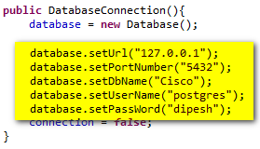

Change the Url, portnumber, dbname, username and password according to your postgres. Then execute the class ExperimentScheduling.java

To execute from simulated data:

Execute the class ExperimentSchedulingDefaultData.java

For chaning the number of jobs, resources and time

In the main class ExperimentScheduling.java and ExperimentSchedulingDefaultData.Java

1 Change the following parameters to define how many jobs you want to allocate and for how long

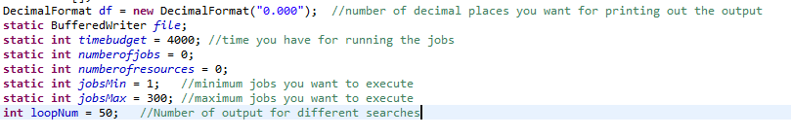

2 Change the following to determine the random job, resources and number of resources to link to the job

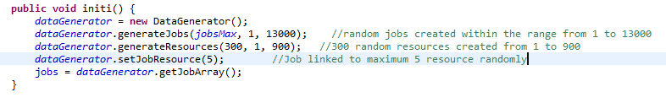

Classes info

* In the package com.controller following classes are listed:

1. DatabaseConnection.java

For connecting to the database.

1. JobController.java

This class gets all the jobs and related resources for the jobs from the database.

1. ResourceController.java

This class gets the resources from the database.

* Package com.data

1. DataGenerator.java

This class generates all the data for simulation job

* Package com.database

1. Database.java

Model class for DatabaseConnection.java

* Package com.model

1. Job.java and Resource.java

Model classes for Job and Resource

* Package simula.ciscojobscheduling

1. ExperimentScheduling.java and ExperimentSchedulingDefault.java

For running two different scenarios

1. Problem_scheduling.java

Returns the fitness function

* Package simula.oclga

All the classes there are for the search algorithm